**BLOOD BANK & DONAR MANAGEMENT SYSTEM**

**Project Report**

**Database Management System**

**In**

**BTech ICT**

**BY**

YUG PATEL (1741017)

ADITYA BAJAJ (1741028)

NISARG GANDHI (1741099)

**Under the guidance of**

**Mentor Name**

**PROFESSOR SHEFALI NAIK**

School of Engineering and Applied Science

Ahmedabad University

Ahmedabad - 380009

**Description:**

The number of persons who are in need of blood are increasing in large number day by day. In order to help people who are in need of blood, Our Online Blood Bank can be used effectively for getting the details of blood donors having the same blood group and within the same city. With the help of Our Online Blood Bank people who are having the thought of donating blood gets registered in Our Online Blood Bank giving his total details.

Our site also helps people who are in need of blood by giving the details of the donors by searching, if at all there are no donors having the same group and within their own city they will be given the addresses with phone numbers of some contact persons in major cities who represent a club or an organization with free of cost.

The present project includes the following features.

* Registering the Donors
* Modification of Donor Information
* Searching a Donor
* Life Saving Contacts (in major cities)

**Data Flow Diagram:**

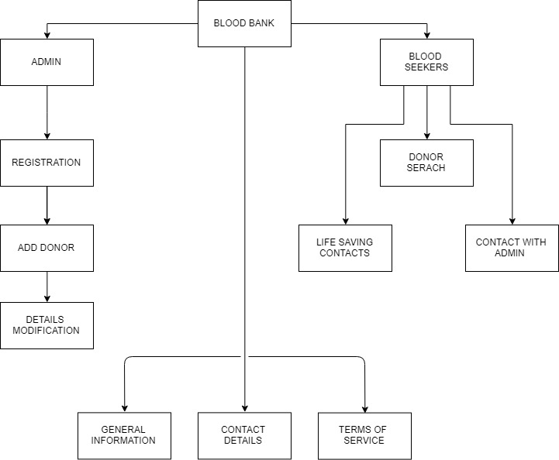

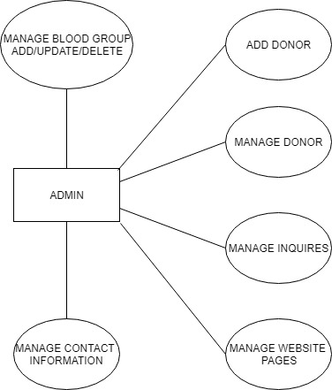

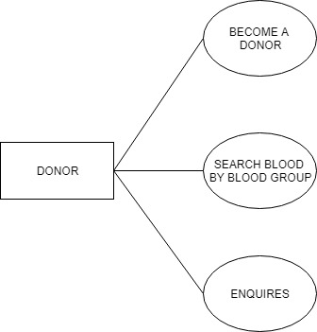

TABLE DESIGN:

Table Name: admin

Description:**- This Table is store info about admin login details**

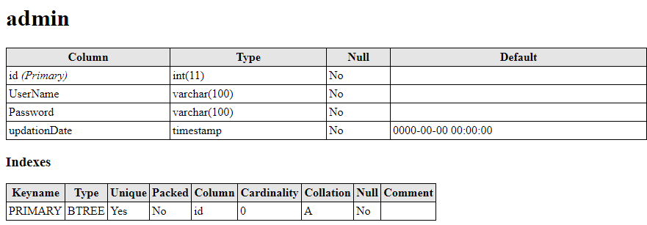

Table Name**:**tblblooddonors

Description:**- This Table is store blood donors information**

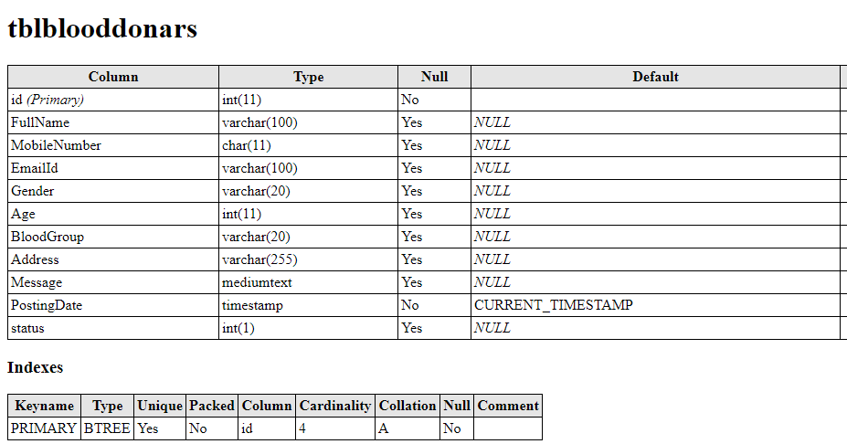

**Table Name : tblbloodgroup**

Description:**- This Table is store blood group info**

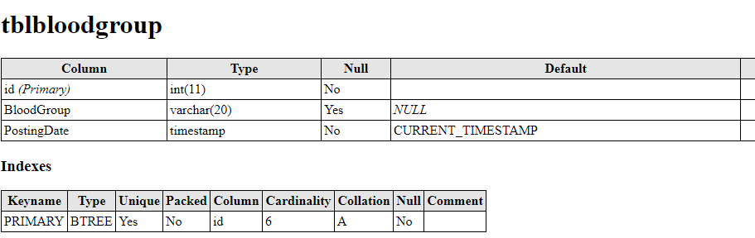

**Table Name: tblcontactusinfo**

Description:**- This Table is store contact information**

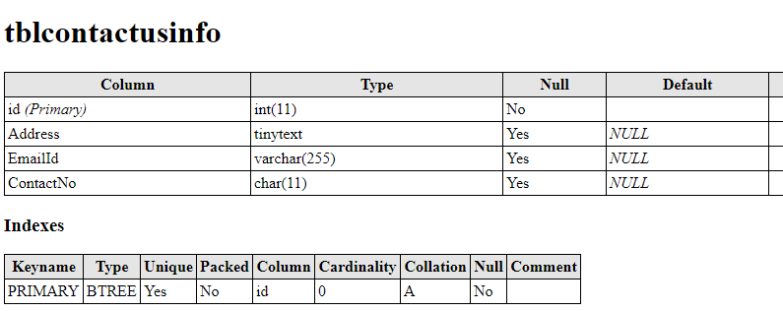

**Table Name: tblcontactusquery**

Description:**- This Table is store enquiry info.**

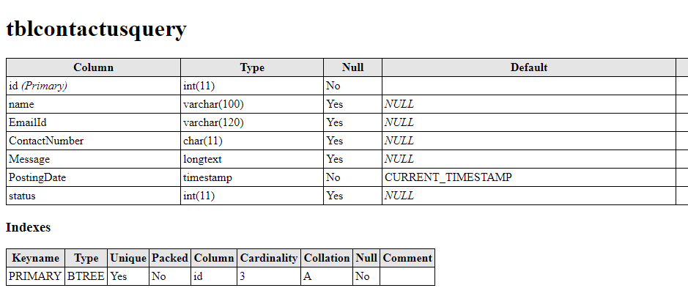

**Table Name: tblpages**

Description:**- This Table is store website pages information**

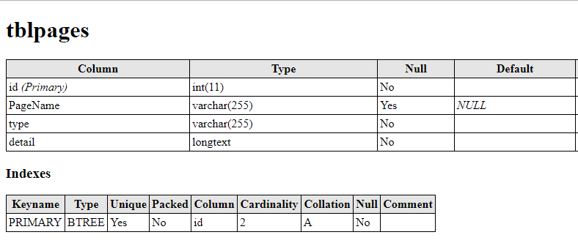

**ER Diagram:**

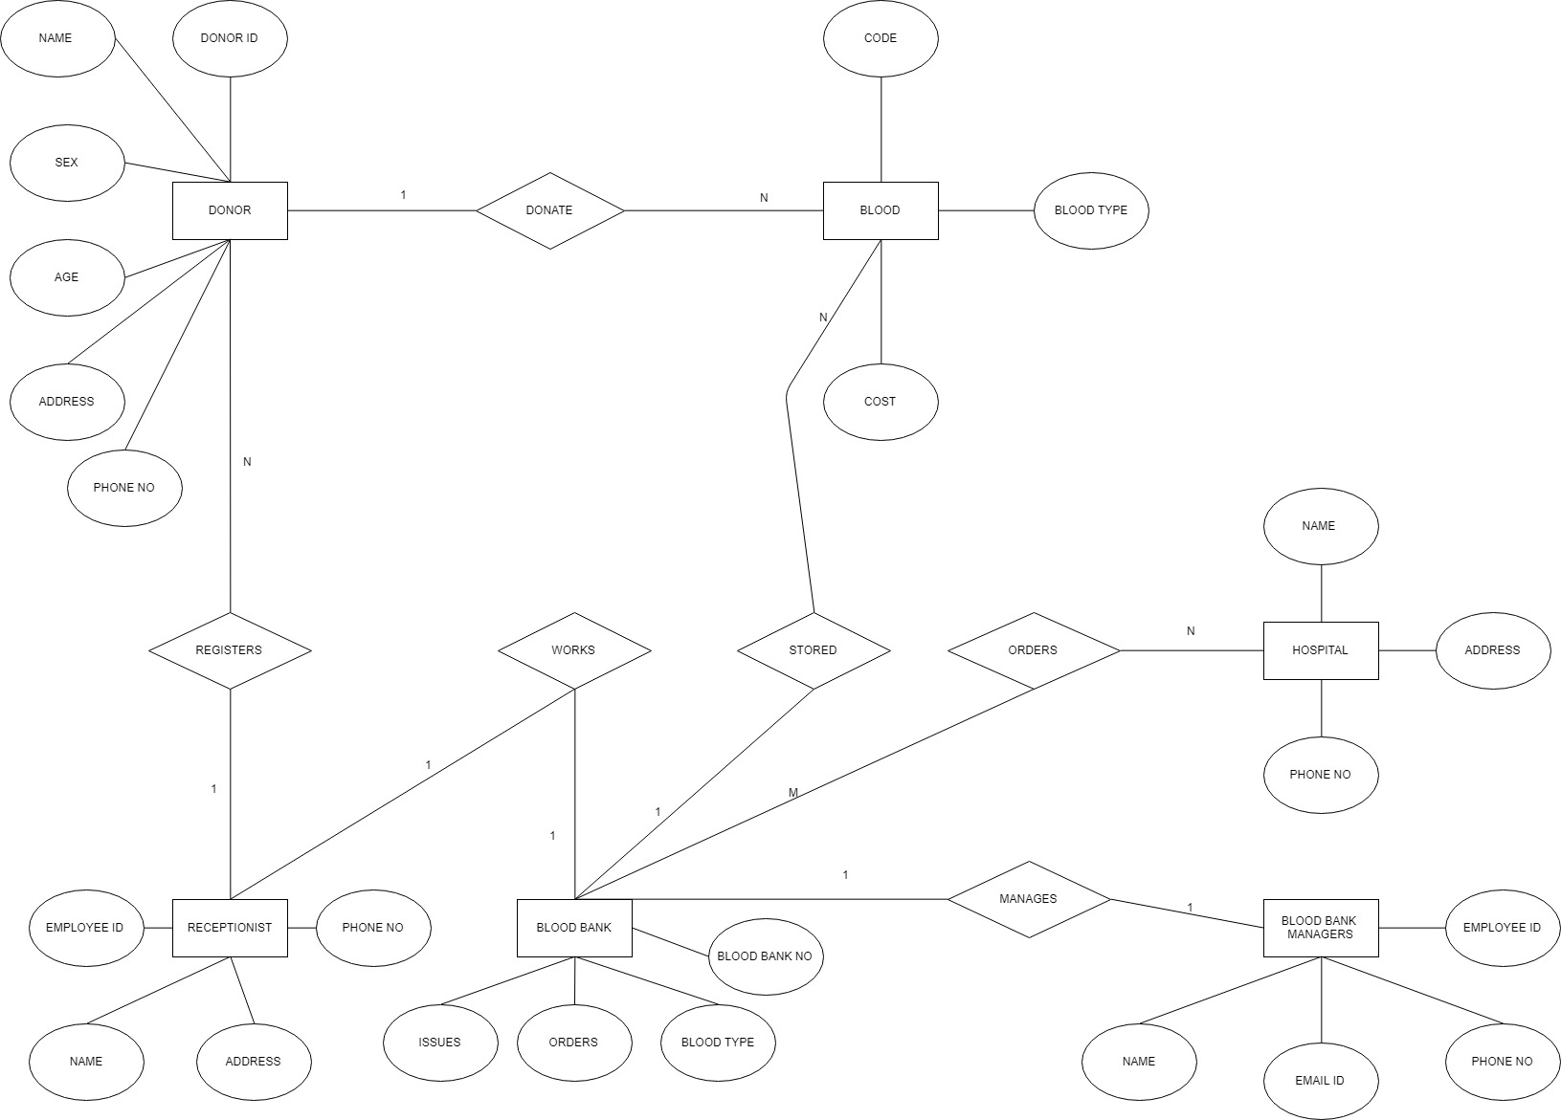

**Screen Shots of Procedure:**

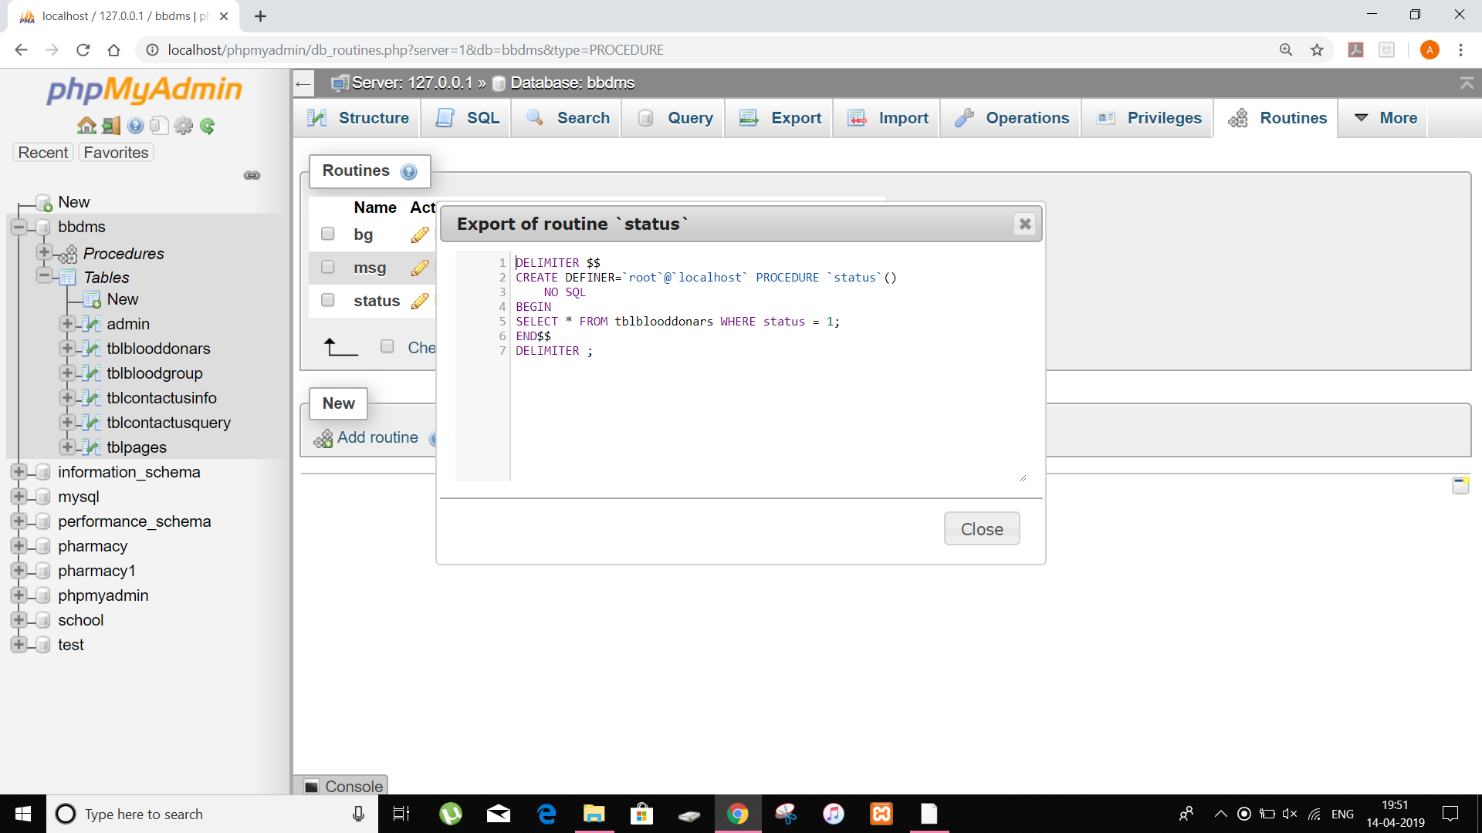

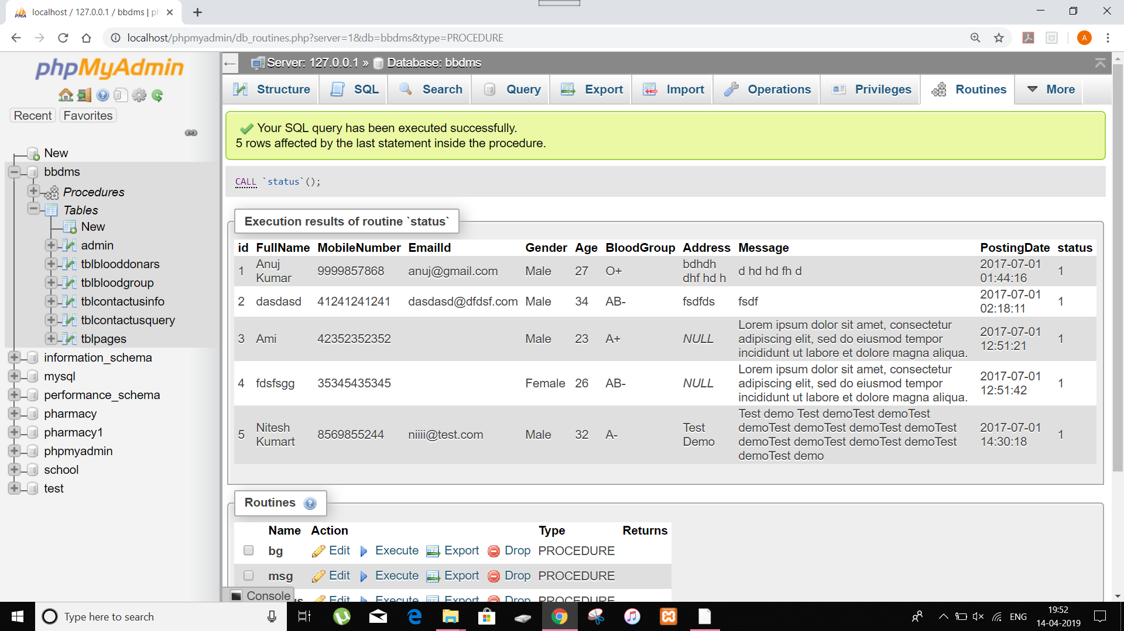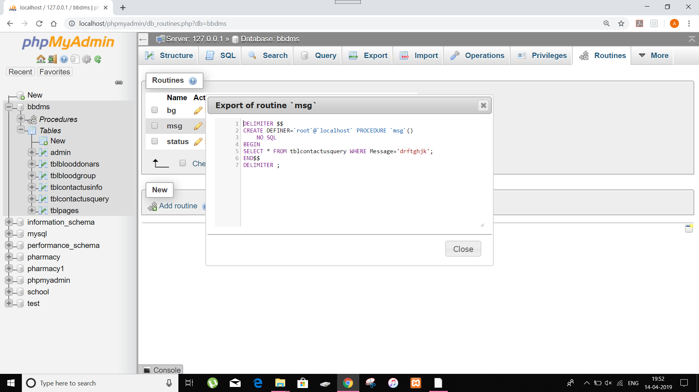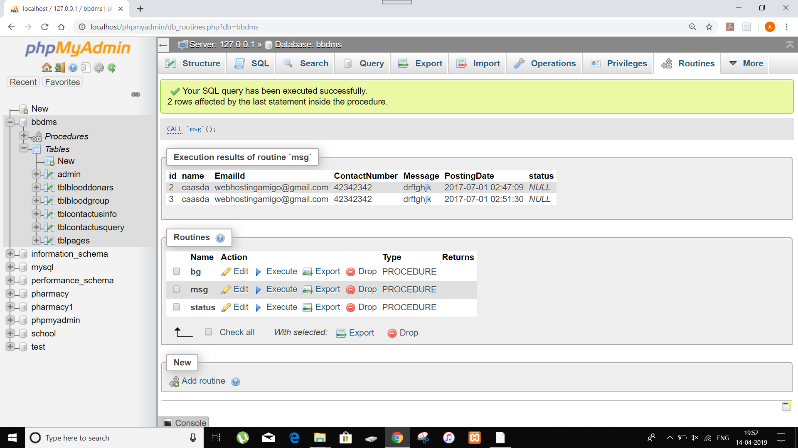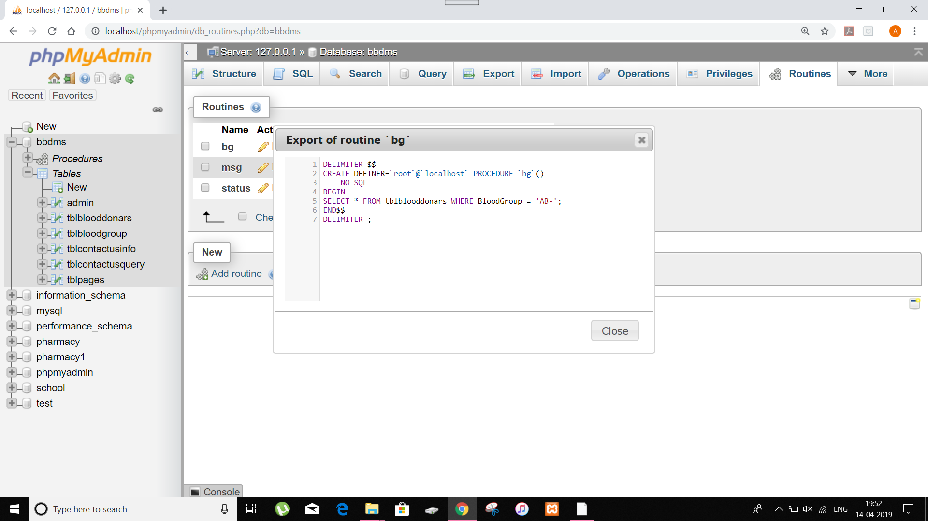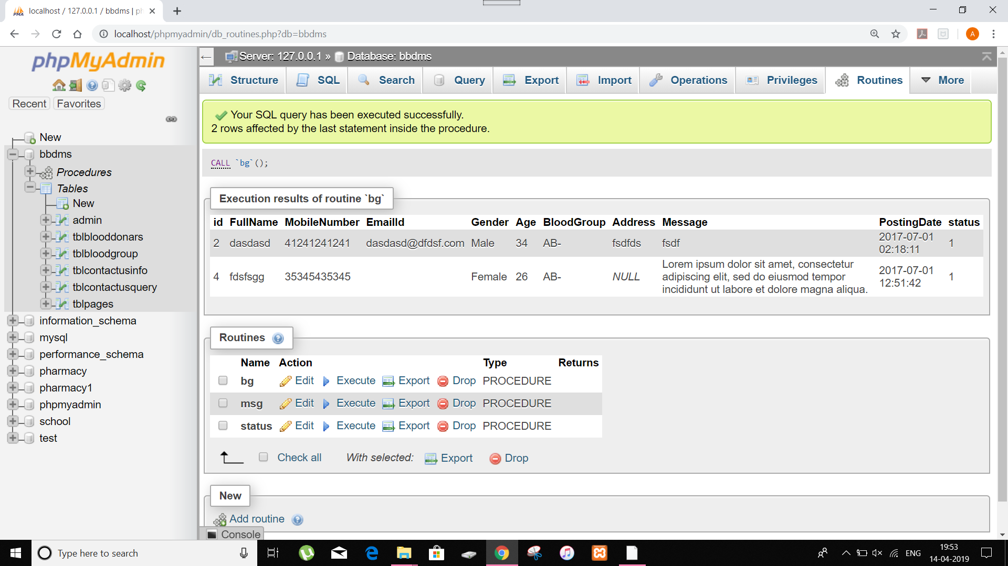

**Screen Shots of Trigger:**

